Assignment 6.6

Problem Statement

Write a map reduce program to use Sequence file as input and save the output in key value output format.

Note : You can use the sequence file output which you have got in the earlier assignment of the same session.

Solution

Driver class

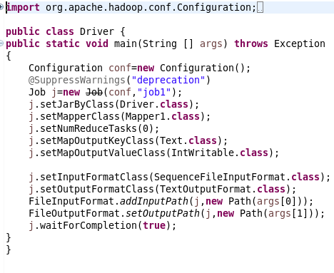

Mapper

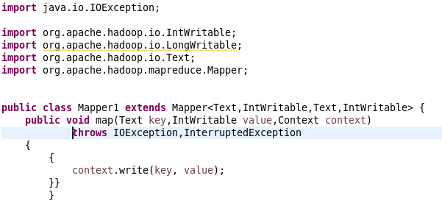

**Jar command**



Output

